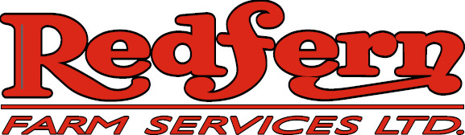

Redfern Farm Services, a progressive service oriented ag retailer is currently accepting applications for Seasonal Class 1 and Class 3 Drivers for our RIVERS retail location:

Qualifications:
• Valid Class 1 or 3 (with air brake endorsement) driver’s license
• Mechanically inclined preferably with a farm background
• Excellent communication skills
• Flexible work schedule with capability of working long hours

Duties and responsibilities:
• Short haul granular, liquid fertilizer, NH3 and chemical
• Willing to be trained in and handle dangerous goods
Perform pre-trip inspections
Maintaining equipment as required

Redfern Farm Services offers a competitive compensation package with excellent earning potential, a team approach and the opportunity for full-time employment for the right individual(s). Interested applicants can submit resumes to the address below.

REDFERN FARM SERVICES
101 2nd Avenue
Rivers, MB R0K 1X0
Attn: Rob McGill
Email: rmcgill@redferns.ca

Redfern Farm Services thanks you for your interest, all applications will be held in confidence
Only those individuals selected will be contacted

