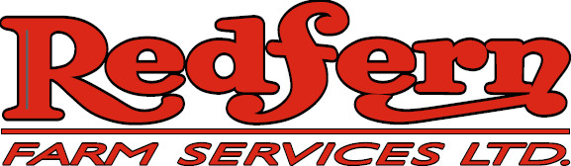

Employment Opportunity
Operations Assistant

A progressive, service-oriented ag retailer is currently accepting applications for a seasonal operations position at our Neepawa location.

The position may turn into full-time status for the right individual

- Loading/unloading fertilizer, crop protection products and seed
- Operate and maintain fertilizer blenders and plant equipment
- Complete preventative maintenance and minor repair on a variety of equipment
- Warehousing and shipping of farm supplies along with general yard work
- Additional responsibilities as required by facility management
- You will also play a key role in providing customer service to our clients.

Education

Ideal candidates will possess a Grade 12 education or equivalent

Skills
- Possess a valid driver’s license, Class 1 or 3 w/air preferred
- Qualified candidates will have mechanical and general maintenance experience
- Able to handle the physical demands of the position and work in a variety of environments
- Self starter, ability to work alone while being a valuable member of a team
- Excellent customer service skills
- Agriculture background is an asset
- Ability to work extended hours in peak season

Redfern’s offers a competitive compensation package.
Interested applicants should submit resumes by February 27, 2026:

Submit your resume and cover letter to:

Redfern Farm Services
Attn: Darryl Craik
PO Box 1480
Neepawa, MB R0J 1H0
204-476-2301 ph
Email:dcraik@redferns.ca

All applications will be held in confidence.
Only those individuals selected will be contacted.

