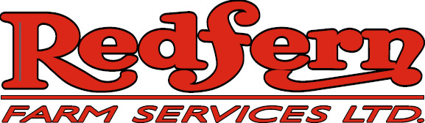

We are a progressive, service oriented ag retailer currently accepting applications for Seasonal Class 1 and Class 3 Drivers (with Air endorsement) for our NEEPAWA retail location:

The position may turn into full-time status for the right individual

Qualifications:
• Valid minimum Class 3 (with air) driver’s license
• Mechanically inclined preferably with a farm background
• Excellent communication skills
• Flexible work schedule with capability of working long hours

Duties and responsibilities:
• Short haul granular and liquid fertilizer, NH3 and chemical
• Willing to be trained in and handle dangerous goods
Perform pre-trip inspections
Maintaining equipment as required

Redfern Farm Services offers a competitive wage.

Submission deadline: until position filled

Submit your resume and cover letter to:

Redfern Farm Services
Attn: Darryl Craik
PO Box 1480
Neepawa, MB R0J 1H0
204-476-2301 ph
Email:dcraik@redferns.ca

All applications will be held in confidence.
Only those individuals selected will be contacted.

