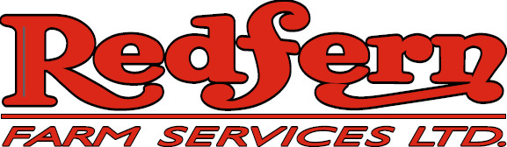

We are a progressive, service oriented ag retailer currently accepting application for a seasonal
Equipment Operator for our Hamiota location.

The position may turn into full-time status for the right individual

As an Equipment Operator, you will be responsible for:

- Perform preventative maintenance and repair on a variety of equipment
- Warehousing and shipping of farm supplies along with general yard work
- Flexible work schedule with capability of working long hours
- Operate agricultural field equipment and delivery units

Skills

- Have mechanical and general maintenance abilities
- Able to handle the physical demands of the position and work in a variety of environments
- Self-starter, ability to work alone while being a valuable member of a team
- Agriculture background is an asset
- Class 1 or 3 (with air) driver’s license would be an asset.

Submission deadline: until position filled

Submit your resume and cover letter to:

Redfern Farm Services
Attn: Todd Hunter
PO Box 660
Hamiota, MB R0M 0T0
204-764-2259 ph
Email:thunter@redferns.ca

All applications will be held in confidence.
Only those individuals selected will be contacted.

